UNIVERSIDAD ANDINA DEL CUSCO
FACULTAD DE INGENIERÍA Y ARQUITECTURA

"Activity in English"
Comparison of Classification Models with Supervised Learning

COURSE: Artificial Intelligence
TEACHER: Espetia Huamanga, Hugo
MEMBERS:
Huamantalla Ríos, Diego Miguel - 022100354D
Latorre Campos, Andre Ismael - 022101034C
Ordóñez Paniura, Marcela Leonor - 022100735H
Suel Monrroy, David Joshua - 022101091G

CUSCO – PERU
2026

Project Presentation
This work applies four supervised classification models to a real-world problem based on environmental sensor data. The activity is organized in three phases: (1) strategic selection and theoretical analysis of the models, (2) classification challenge with experimentation and rigorous validation, and (3) final comparative verdict on the best model in terms of performance and computational cost.
The four selected models belong to different mathematical families, as required by the activity: Support Vector Machines (SVM) and K-Nearest Neighbors (KNN) from the geometric and distance-based family; Gaussian Naive Bayes from the probabilistic family; and Gradient Boosting from the ensemble family. The chosen dataset was the “Occupancy Detection Dataset”, on which all four algorithms competed on equal terms through a unified preprocessing pipeline.

Phase 1: Theoretical Matrix
According to the activity rules, each team had to select four models ensuring at least one model from each mathematical family. The selected combination was:
• Family 1 (Geometric and distance-based): Support Vector Machines (SVM) and K-Nearest Neighbors (KNN), evaluating different kernels and distance metrics.
• Family 2 (Probabilistic and generative): Gaussian Naive Bayes (GaussianNB).
• Family 3 (Ensemble and stochastic): Gradient Boosting.
Table 1 contrasts the four models according to the four requested criteria: core mathematical principle, sensitivity to outliers, computational cost, and assumptions about data distribution.
Model | Core Mathematical Principle | Sensitivity to Outliers | Computational Cost | Assumptions about Data Distribution
Support Vector Machines (SVM) | Margin maximization (distance) between classes using hyperplanes. Applies the “kernel trick” to project the data into higher dimensions. | Low to Medium. Strongly depends on the support vectors: if an outlier lies close to the margin, it can shift the hyperplane. | High. Training scales quadratically with the number of instances (O(n²)), and requires tuning C, gamma and the kernel. | Assumes no specific underlying distribution (non-parametric model); it only depends on the geometry of the data.
Gaussian Naive Bayes (GNB) | Bayes’ Theorem combined with the assumption of conditional independence among the predictor variables. | Moderate to High. When estimating means and variances, extreme values can bias the parameters of the distributions. | Very Low. Highly efficient in both training and prediction; requires few resources. | Assumes that the numeric features follow a Normal (Gaussian) distribution and that all variables are independent of each other.
Gradient Boosting | Stochastic and sequential ensemble: it iteratively combines weak decision trees, where each new tree minimizes the residual errors of the previous one through gradient descent. | Low. It is inherently robust to outliers thanks to the base trees and robust loss functions. | Very High. Trains multiple trees sequentially (not natively parallelizable like Random Forest), demanding much time and memory. | Makes no mathematical assumptions about the data distribution or the spatial relationship among variables.
K-Nearest Neighbors (KNN) | Classification based on spatial distance (Euclidean, Manhattan, etc.) to the k nearest neighbors in feature space. | High. Being distance-based, a single outlier can erroneously become the “nearest neighbor” of a new sample. | Low in training, high in prediction (lazy learning). Computing distances against all instances is costly in large datasets. | Assumes no prior distribution, but does assume that samples with similar features belong to the same class (spatial locality).
Table 1. Comparative theoretical matrix of the four classification models.

Phase 2: The Classification Challenge

2.1. Dataset: Occupancy Detection
The “Occupancy Detection Dataset” was selected, an environmental sensor data classification problem (the suggested category of “environmental sensor data”). The goal is to predict whether a room is occupied (1) or empty (0) from sensor readings recorded approximately every minute.
The original dataset is distributed in two files (training and test). For this experiment both were concatenated, obtaining a total of 17,895 instances, well above the required minimum of 2,500. Two non-predictive columns were removed: the unnamed index column (“Unnamed: 0”) and the date/time column (“date”), since their use could introduce temporal artifacts and information leakage.
Variable | Description | Type
Temperature | Ambient temperature (°C) | Numeric predictor
Humidity | Relative humidity (%) | Numeric predictor
Light | Light intensity (lux) | Numeric predictor
CO2 | Carbon dioxide in the air (ppm) | Numeric predictor
HumidityRatio | Humidity ratio (kg water / kg dry air) | Numeric predictor
Occupancy | Room state: 0 = empty, 1 = occupied | Binary target
Table 2. Dataset variables. Five numeric predictors and one binary target variable.

Class distribution:
14,117 instances of empty room (78.9%) versus 3,778 of occupied room (21.1%). The dataset is imbalanced, so accuracy would not be a reliable metric: a classifier that always predicted “empty” would reach 78.9% accuracy without learning anything. Therefore, the main evaluation metric is the average (macro) F1-Score.

2.2. Unified preprocessing pipeline
So that the four models compete on equal terms, a single pipeline was built consisting of a StandardScaler (z-score normalization) followed by the classifier. Scaling is essential for distance-based models (KNN) and margin-based models (SVM), since variables such as light (hundreds of lux) and humidity ratio (units of 10⁻³) are on very different scales.
Importantly, the StandardScaler sits inside the Pipeline passed to GridSearchCV: in this way, the scaling statistics are learned only with the training folds of each validation, avoiding data leakage.
pipeline = Pipeline([
("scaler", StandardScaler()),
("clf", classifier),
])

2.3. Training and hyperparameter optimization
Each model was optimized with GridSearchCV, an exhaustive search over the hyperparameter grids shown in Table 3, using the macro F1-Score as the search metric. For SVM, three different kernels were evaluated (kernel analysis) and for KNN two distance metrics (distance-metric evaluation), as required by the geometric family.
Model | Hyperparameter grid (GridSearch) | # combinations
SVC | kernel: [rbf, linear, poly] · C: [0.1, 1, 10] · gamma: [0.01, 0.1, 1] | 27
GaussianNB | var_smoothing: [1e-9, 1e-8, 1e-7] | 3
GradientBoosting | n_estimators: [50, 100] · max_depth: [2, 4] · learning_rate: [0.05, 0.1] | 8
KNN | n_neighbors: [3, 5, 7] · weights: [uniform, distance] · metric: [euclidean, manhattan] | 12
Table 3. Hyperparameter grids evaluated by GridSearchCV for each model.

2.4. Cross-validation
To guarantee that results do not depend on a lucky data split, stratified cross-validation with 5 folds was used (StratifiedKFold, 5 splits, shuffle=True, random_state=42). The stratified version keeps the original class proportion (78.9% / 21.1%) in every fold, which is the most rigorous choice given the class imbalance. The reported F1-Score is the average over the five folds.

2.5. Experimental results
Table 4 summarizes the final performance of each model after optimization. KNN achieved the best macro F1-Score (0.9923) with the lowest computational load among the top three. The best hyperparameters found were:
Model | F1-Score (macro) | Accuracy | Precision (macro) | Recall (macro) | Total time (s) | Best hyperparameters
KNN | 0.9923 | 0.9949 | 0.9912 | 0.9934 | 1.21 | n_neighbors=5, weights='distance', metric='euclidean'
SVC | 0.9900 | 0.9933 | 0.9869 | 0.9931 | 34.51 | C=10, gamma=1, kernel='rbf'
GradientBoosting | 0.9886 | 0.9923 | 0.9866 | 0.9906 | 8.75 | n_estimators=100, max_depth=4, learning_rate=0.1
GaussianNB | 0.9530 | 0.9670 | 0.9327 | 0.9784 | 0.17 | var_smoothing=1e-9
Table 4. Final results: average macro F1-Score from cross-validation (StratifiedKFold, 5 folds). Precision/recall/accuracy were estimated with out-of-fold predictions.

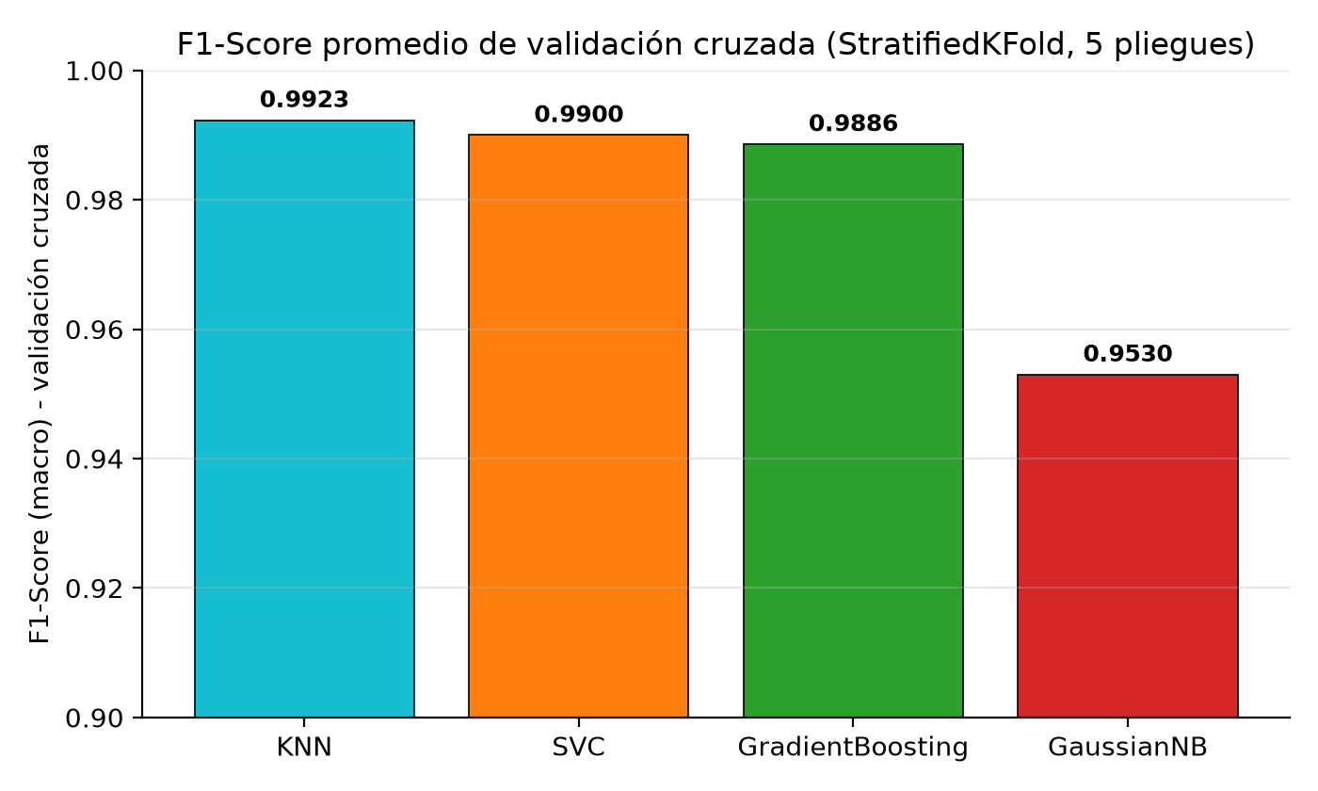
Figure 1. Average macro F1-Score from cross-validation per model.
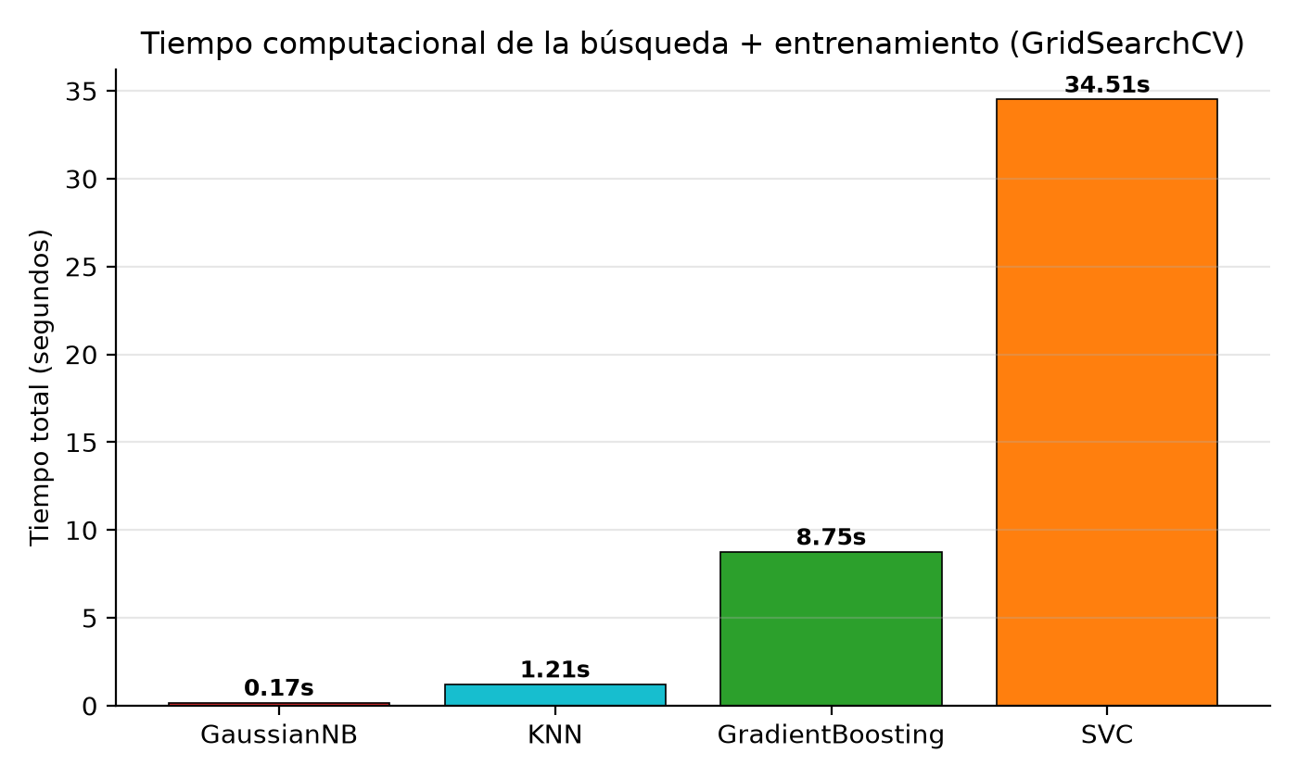
Figure 2. Total computational time (search + training) per model.

2.6. Kernel analysis in SVM and distance metrics in KNN
As required by the geometric family, different kernels were analyzed for SVM. The RBF kernel was clearly superior, followed by the linear and then the polynomial kernel. For KNN, the Euclidean metric barely outperformed Manhattan, indicating that the geometric structure of the problem favors straight-line distance.
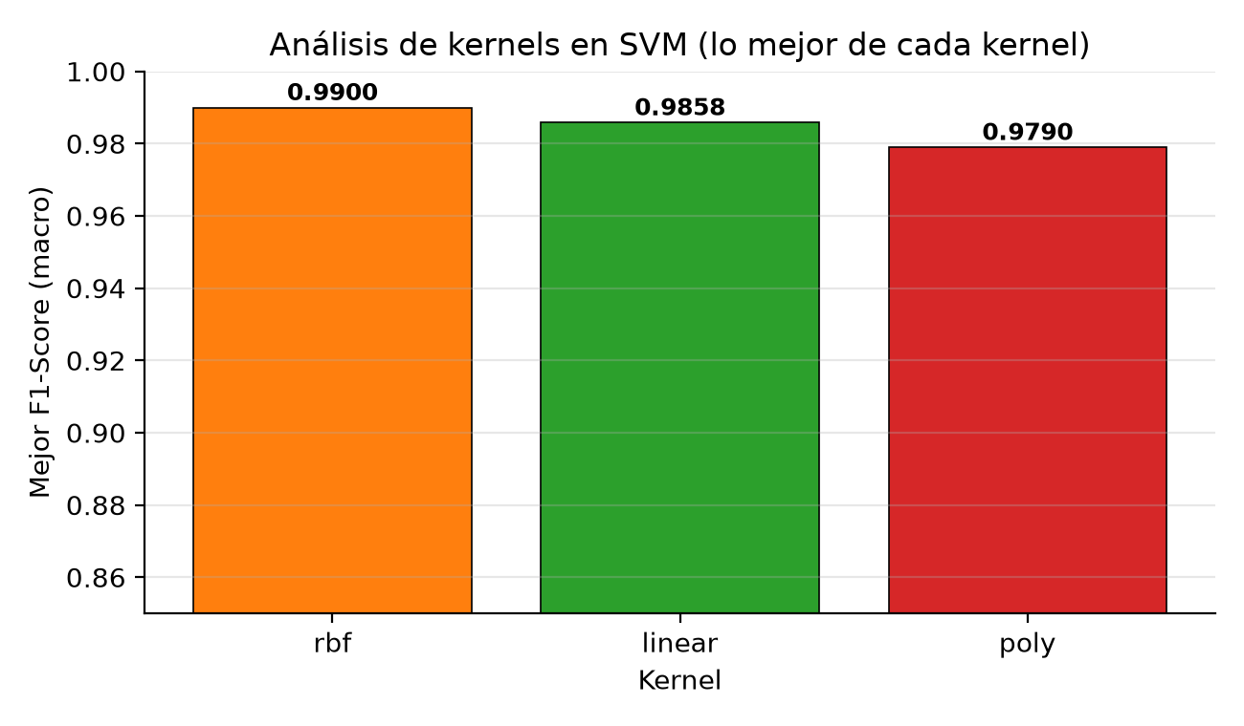
Figure 3. Best F1-Score achieved by each SVM kernel.
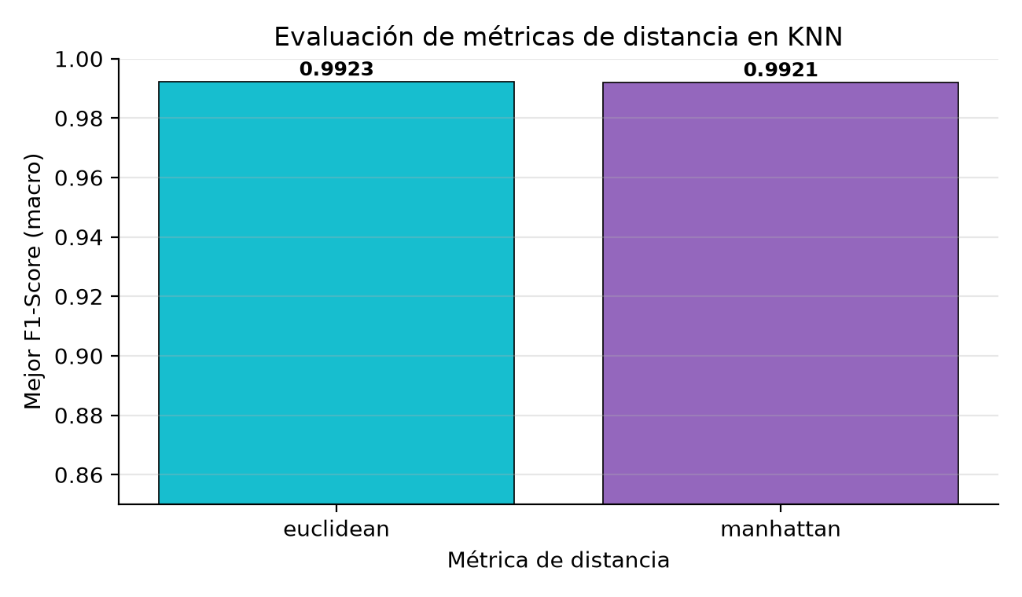
Figure 4. Best F1-Score achieved by each KNN distance metric.

2.7. Confusion matrices
The confusion matrices were built with out-of-fold predictions (each instance was predicted by a model trained without it). They make it possible to quantify the errors of each model:
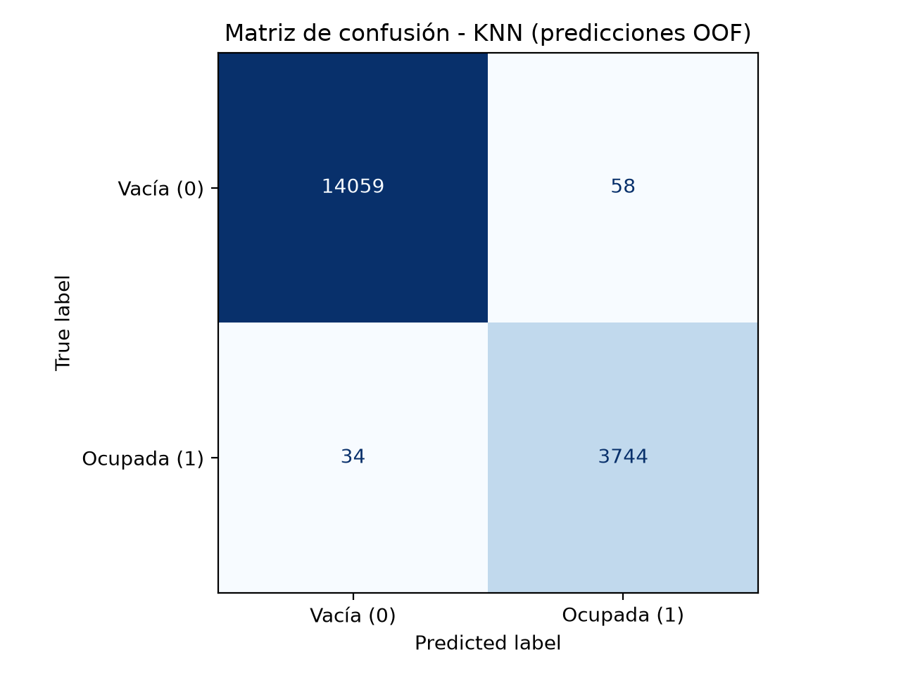  KNN — errors: 58 FP, 34 FN | 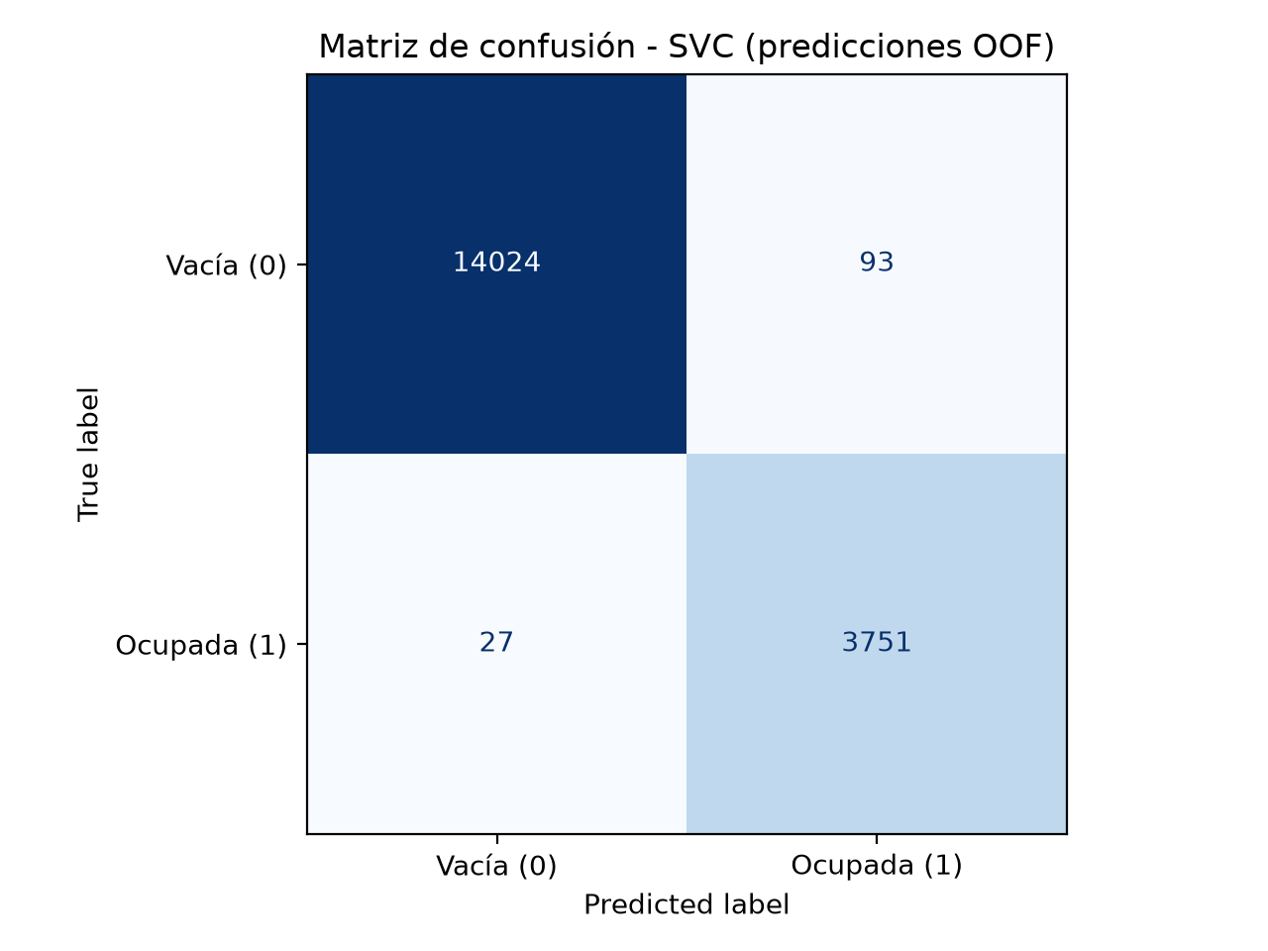  SVC — errors: 93 FP, 27 FN
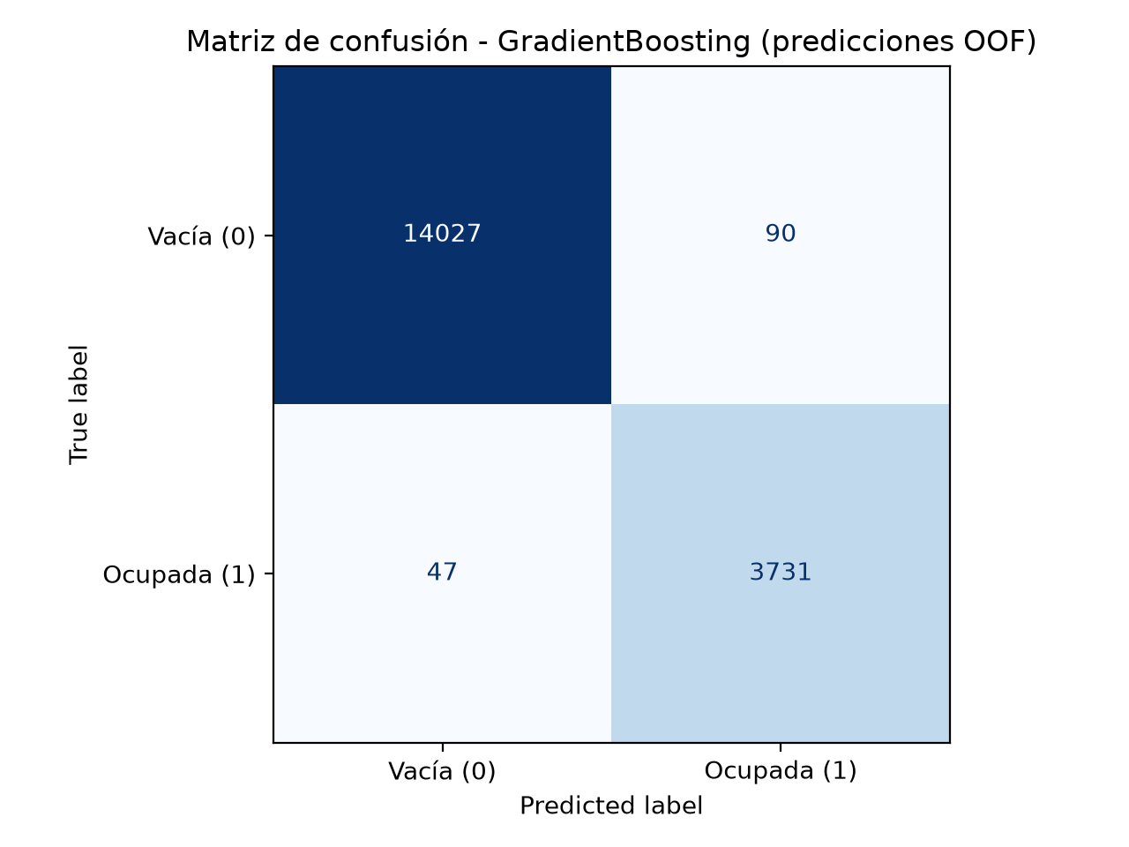  GradientBoosting — errors: 90 FP, 47 FN | 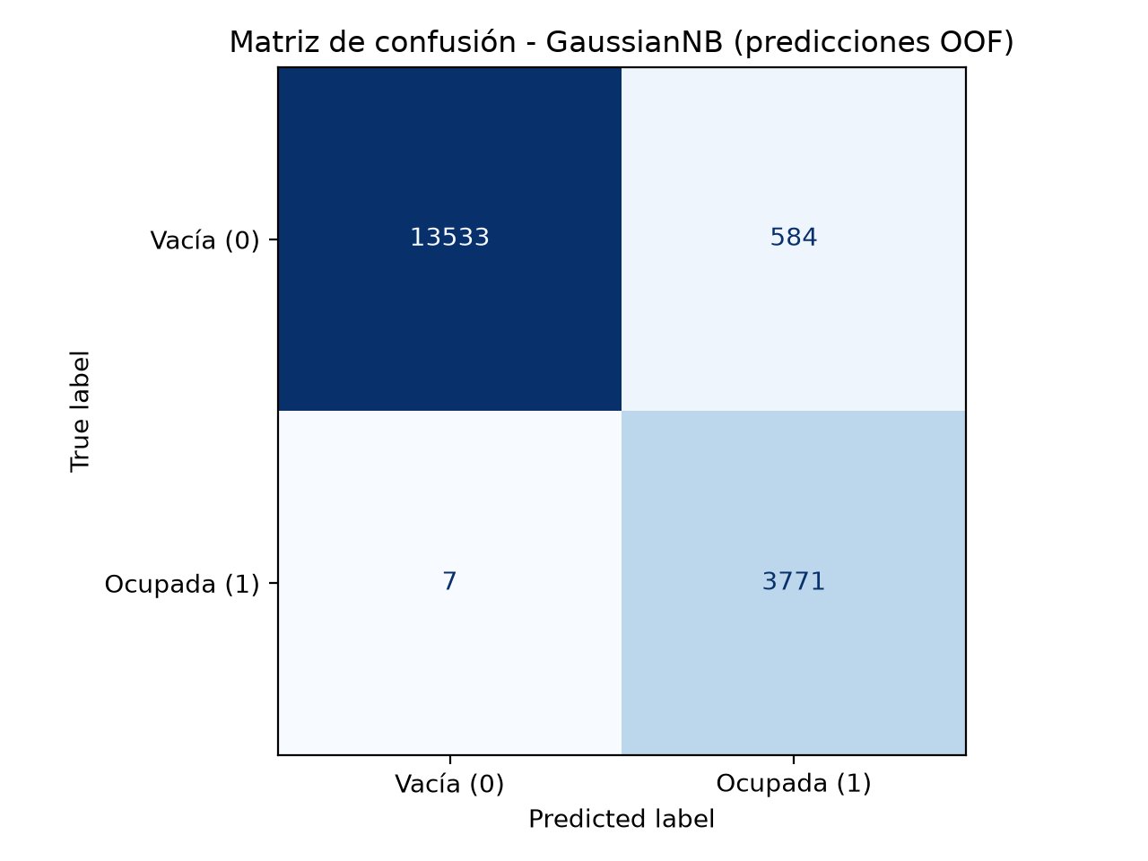  GaussianNB — errors: 584 FP, 7 FN

Figures 5–8. Confusion matrices of the four models (out-of-fold predictions). FP = false positives, FN = false negatives.

2.8. Interactive application (Streamlit)
Additionally, a web interface was developed with Streamlit (app_occupancy.py) that replicates the experiment and runs it at the click of a button, displaying the results table, the best hyperparameters per model and an interactive F1-Score bar chart. It facilitated capturing orderly screenshots for the report.
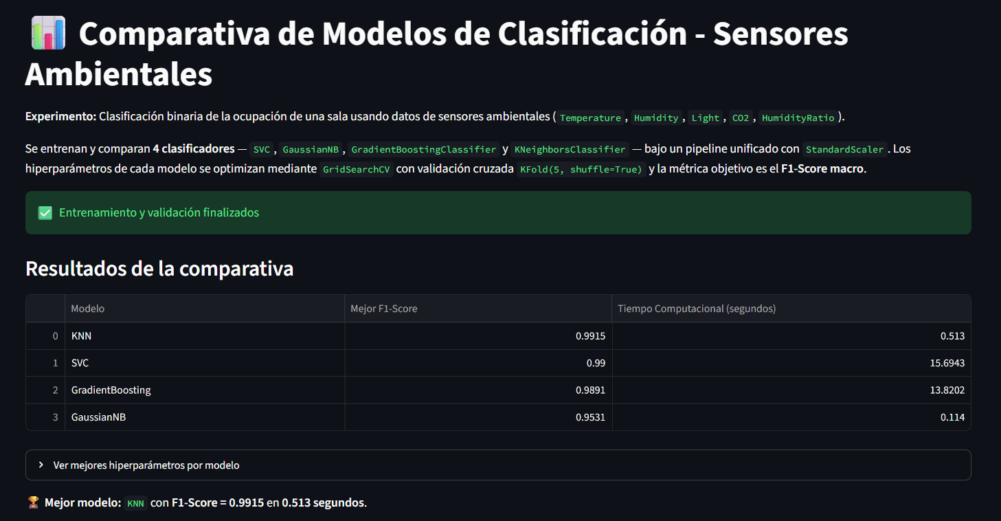
Figure 9. Screenshot of the Streamlit app showing the model comparison.

Phase 3: The Verdict
Based on the experimental results, the three final analysis questions are answered below.

3.1. Balance between accuracy and generalization capability (F1-Score)
After stratified cross-validation, the model that showed the best balance between accuracy and generalization was KNN, with an outstanding macro F1-Score of 0.9923 and an accuracy of 0.9949. This metric balances almost perfectly false positives and false negatives when predicting room occupancy (58 FP and 34 FN out of 17,895 instances), beating by a noticeable margin the lowest-performing model, Gaussian Naive Bayes, which reached 0.9530 (with 584 false positives: it predicted “occupied” on 584 empty-room readings). Using the macro F1 guarantees that the result is not distorted by the class imbalance (78.9% of empty rooms).

3.2. Did the most complex model justify its computational cost?
No. In this experiment, the mathematically more complex models did NOT justify their high computational cost at all. While SVC (34.51 s) and Gradient Boosting (8.75 s) reached slightly lower F1-Scores (0.9900 and 0.9886), KNN obtained the winning score (0.9923) by running the whole process in just 1.21 seconds, and GaussianNB did it in 0.17 s. The simplicity of computing Euclidean distances clearly beat the effort of building sequential trees or projecting multidimensional hyperplanes. The extra cost of SVC and Boosting did not translate into better performance, so for this problem the additional complexity is not profitable.
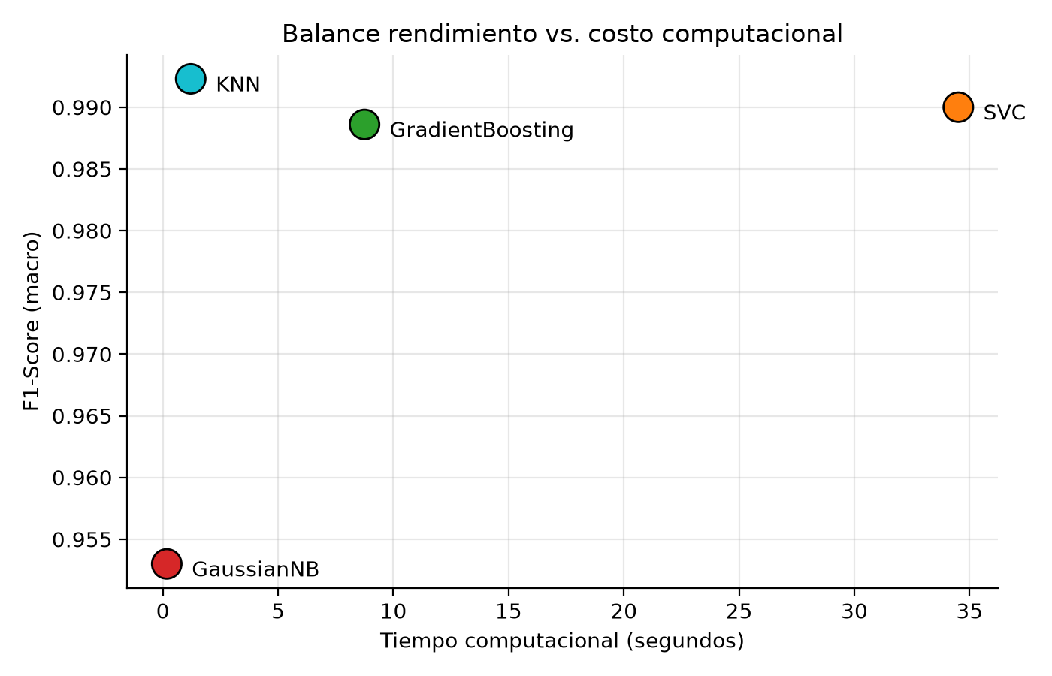
Figure 10. Performance (F1-Score) versus computational cost: the optimal quadrant is top-left.

3.3. Decision boundaries and problem dimensionality
The dataset has five environmental variables (Temperature, Humidity, Light, CO2, HumidityRatio). Projecting the data onto its two first PCA components retains about 82% of the variance (46.4% + 35.8%), which indicates an intrinsically low-dimensional structure. In that projection (Figure 11), the classes (empty vs. occupied room) form dense and spatially separated clusters: when people are present, light and CO2 rise simultaneously, grouping the occupied-class points.
This structure explains KNN’s triumph: it drew decision boundaries based purely on data proximity, without rigid assumptions, and its frontier almost coincides with the natural separation of the clusters. SVC (RBF kernel) and Gradient Boosting achieved almost equivalent boundaries, but at a much higher computational cost. On the opposite end, GaussianNB drew an overly rigid probabilistic boundary: by assuming independence and normality among variables that are actually correlated (Light and CO2, because of their link to human presence; Temperature and HumidityRatio), its boundary was displaced and produced the highest number of false positives of the four models. The low effective dimensionality prevented the curse of dimensionality, favoring distance-based techniques over the parametric frontiers of Naive Bayes.
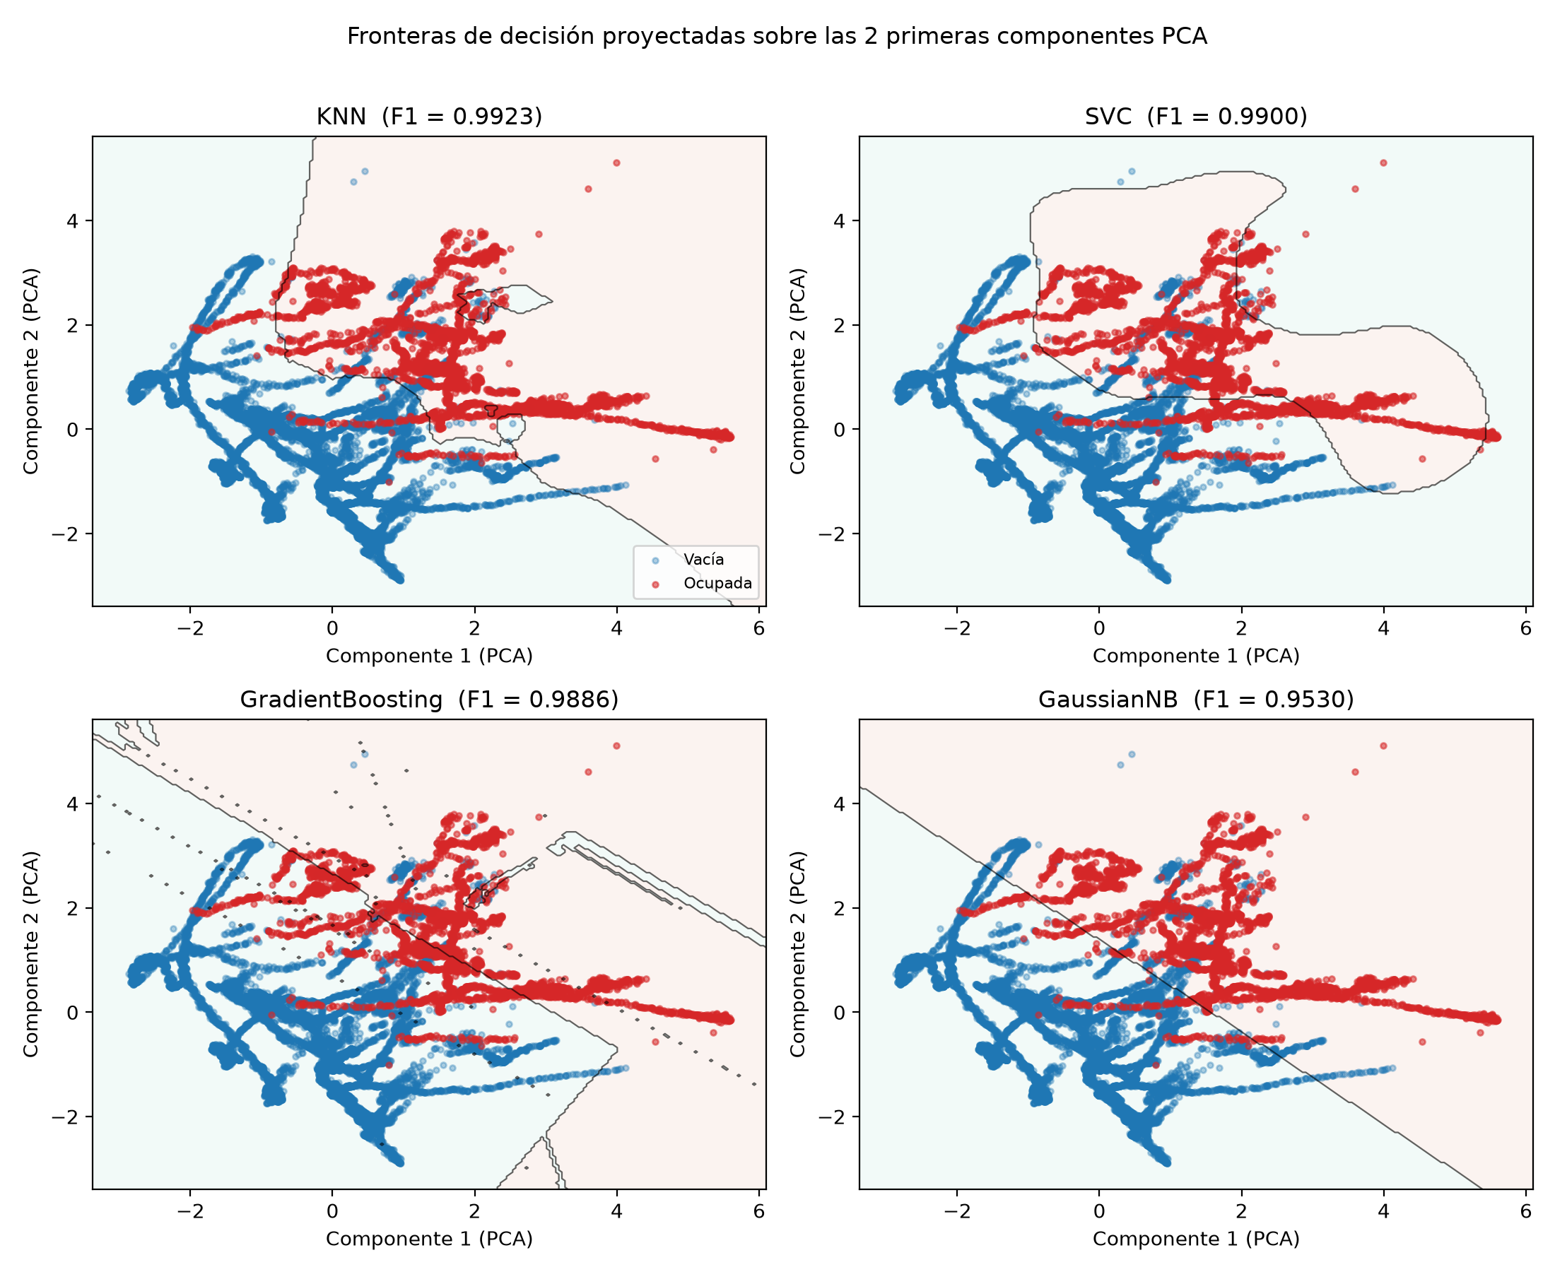
Figure 11. Decision boundaries of the four models projected onto the two first PCA components.
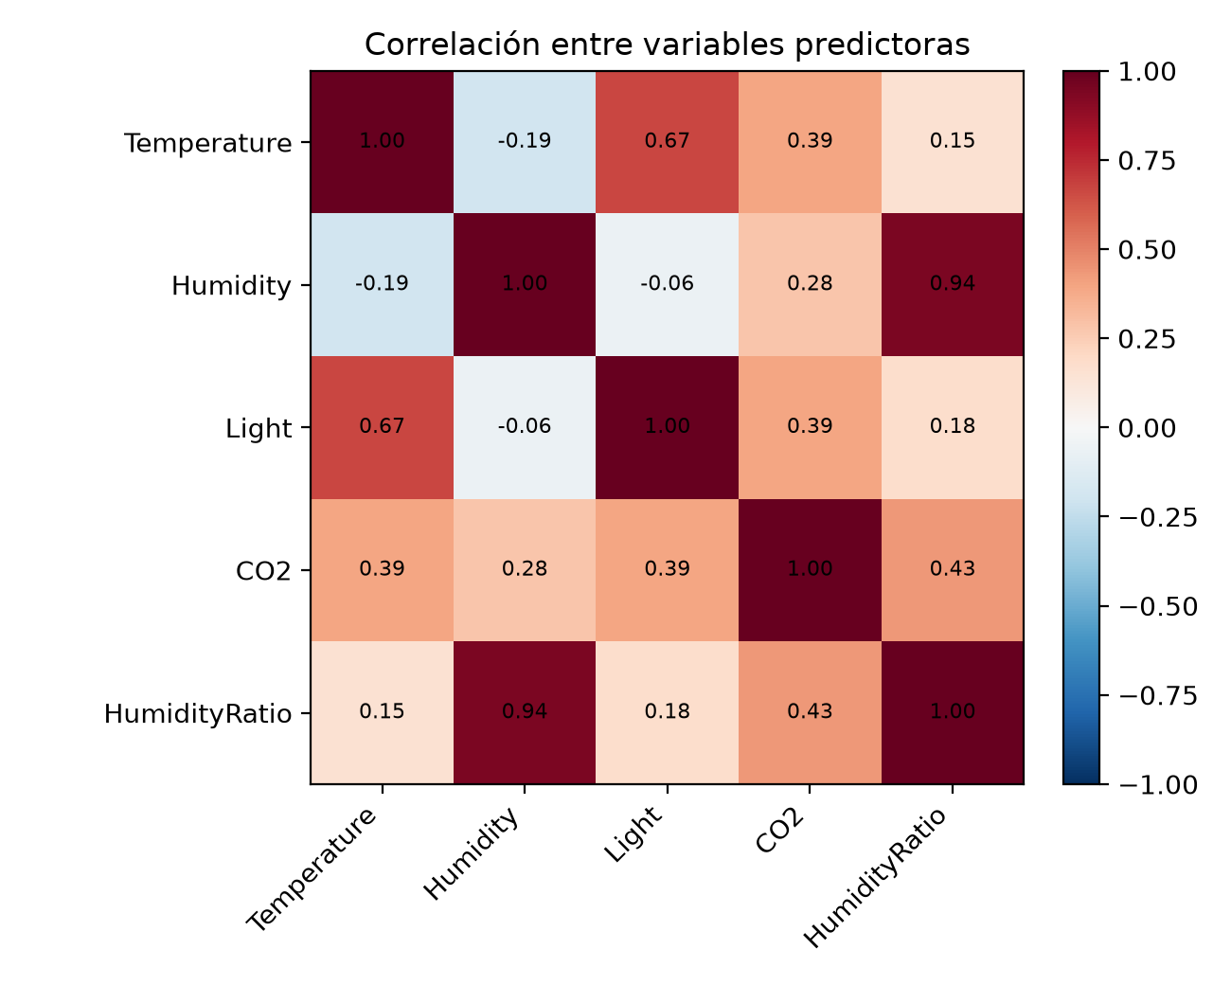
Figure 12. Correlation among the predictor variables (supports the analysis on Gaussian Naive Bayes).

3.4. Final conclusion
KNN with k=5, distance weighting and the Euclidean metric was the winning model, achieving the best F1-Score with the lowest computational cost among the three high-performing models. The complex models (SVC and Gradient Boosting) did not justify their extra cost in this problem, and the probabilistic model (GaussianNB) lagged behind because its independence assumptions were violated. The practical lesson: for low-dimensional problems with well-separated classes, a simple geometric method such as KNN can be the most efficient and accurate option.

Annex: Reproducibility
All experiment files are located in the ActividadIngles folder. The results presented in this report were generated with the following procedure:

A.1. Code and execution
File | Description | Command
occupancy_classification.py | Complete console experiment (data, pipeline, GridSearchCV, results) | python occupancy_classification.py
app_occupancy.py | Interactive Streamlit app of the experiment | streamlit run app_occupancy.py
generar_graficos.py | Generates all the figures of this report in ./graficos | python generar_graficos.py
generar_informe_en.py | Generates this final Word document | python generar_informe_en.py
Table 5. Project files and commands to reproduce each part.

A.2. Dependencies
numpy, pandas, scikit-learn, matplotlib, streamlit, python-docx

A.3. Experimentation flow summary
1. Load and concatenate DataTraining.csv + DataTest.csv -> 17,895 rows
2. Cleanup: remove 'Unnamed: 0' and 'date'
3. Unified pipeline: StandardScaler + classifier
4. GridSearchCV (scoring = macro F1, cv = StratifiedKFold(5))
5. Sort results by F1-Score and computational time

